1. Download for free from website

<https://www.rs-online.com/designspark/pcb-download-and-installation>

1. After installed to window, open by clicking on the Icon

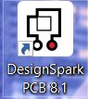

1. The program/software look like this

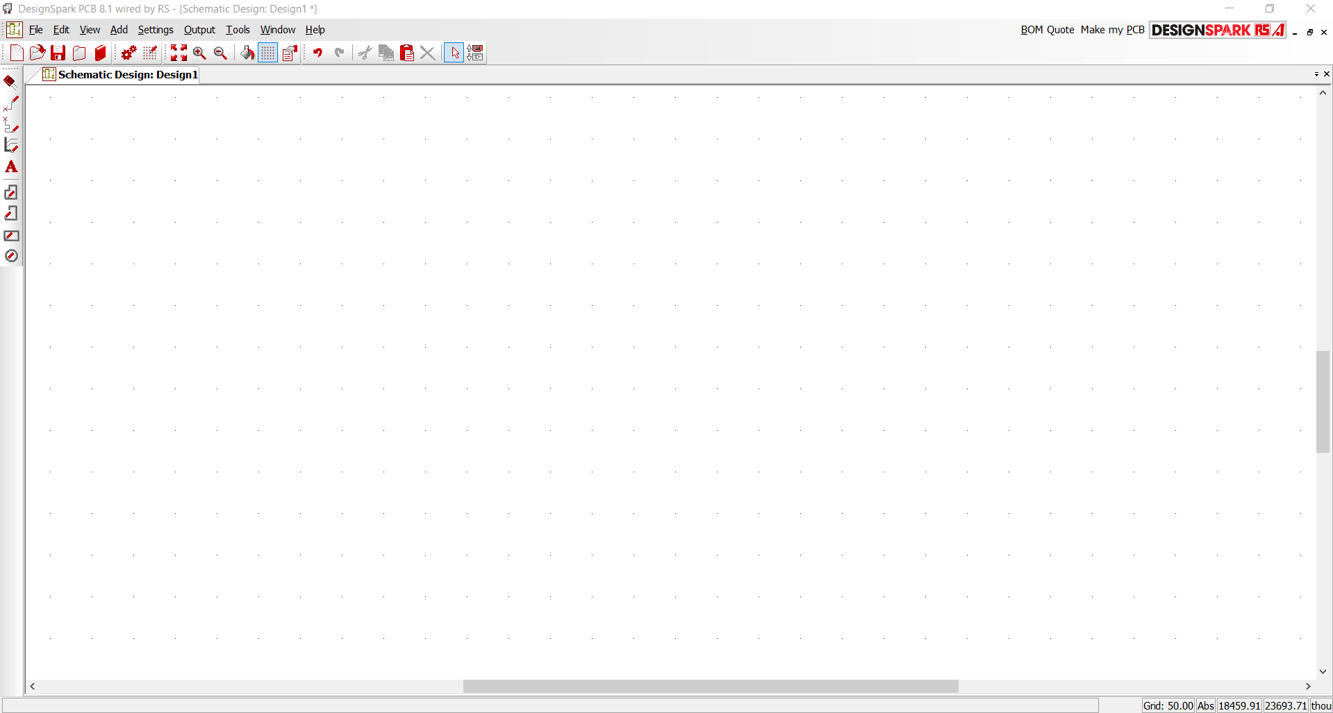

1. Click on the (CTRL+N) or the highlighted icon to create a new project.

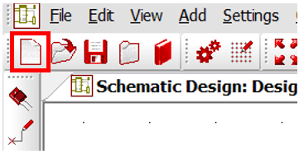

1. Can choose as a project/ schematic Design only or pcb design only.

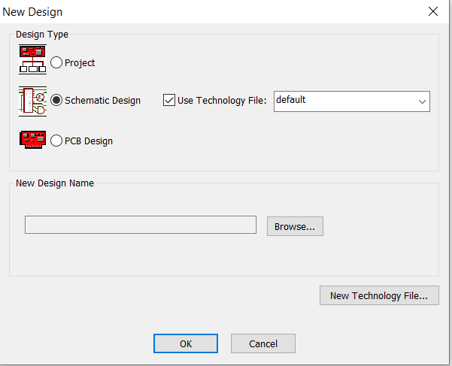

1. To add the component, click on F3 or the icon highlighted with a red box

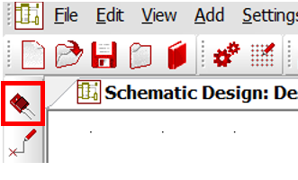

1. You may search the component one by one or simply click on ‘Find’ function to search the component with the keyword.

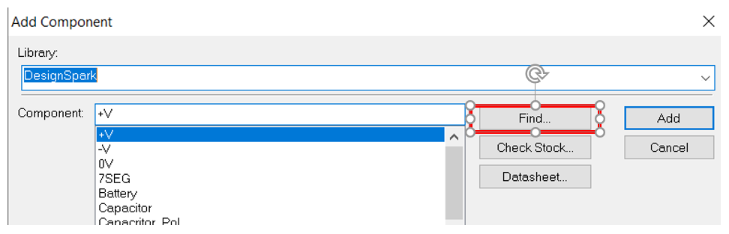

1. May choose different searching criteria to help you find the component easier..

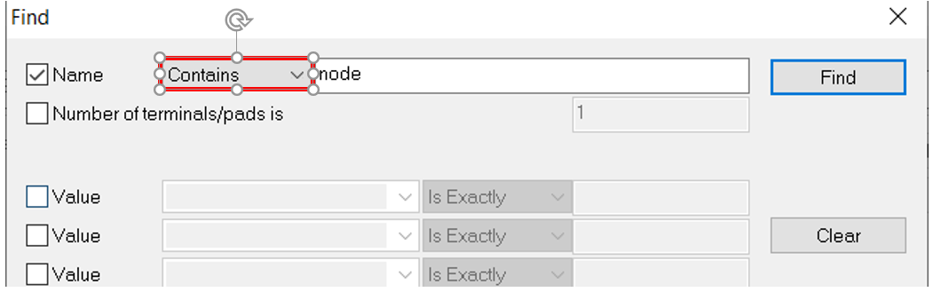

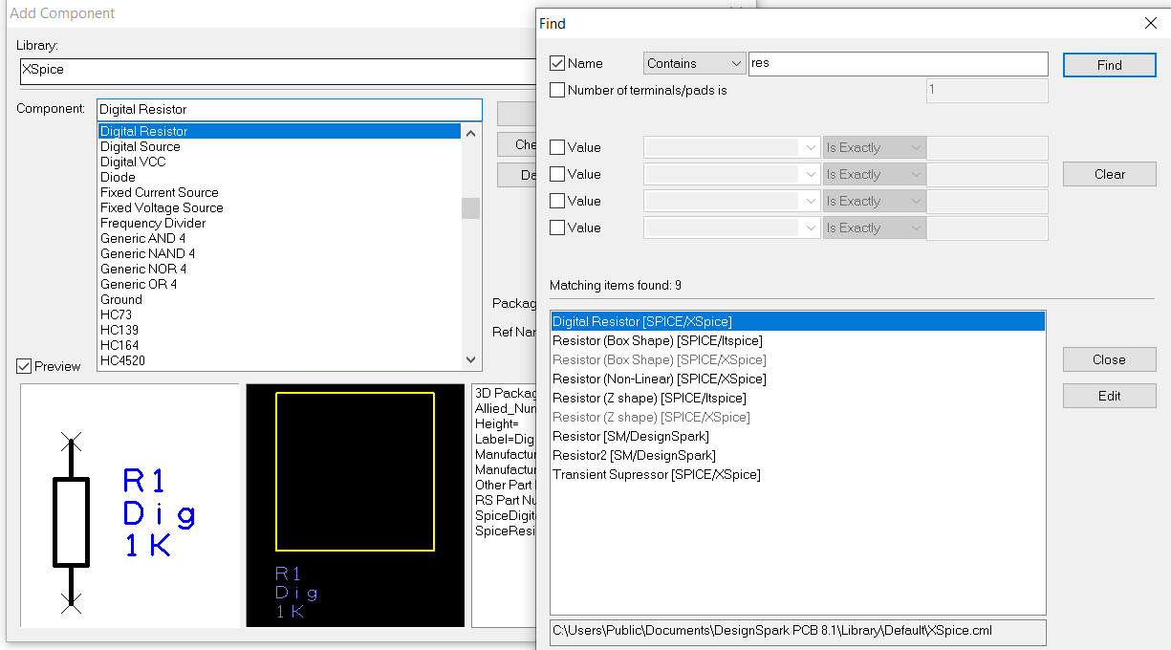

1. Close the ‘Find’ function video and click on add to add the component to schematic.

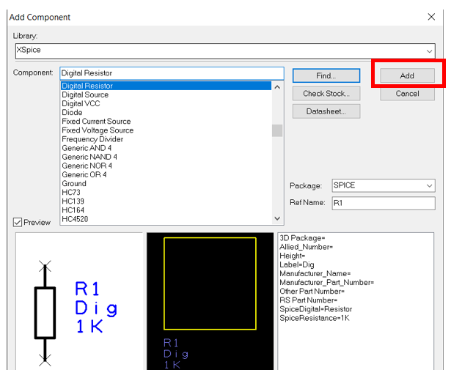

1. You may place the component to the place you want.

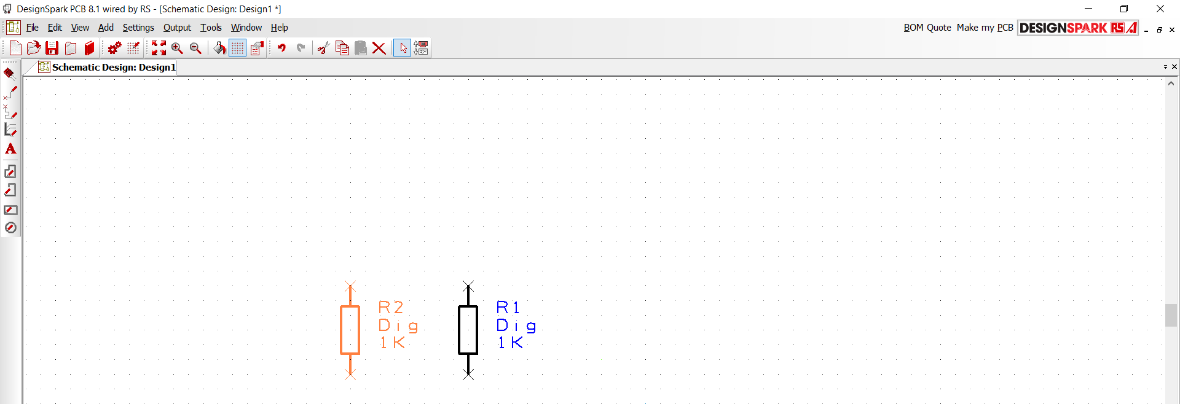

* Click r to rotate the component.
* Click f to flip.
* Double click on the component to edit the specification.
* Double click on the ‘x’ at the leg of the component to connect up the component
* Using mouse to scroll up for focus and vise versa (mouse point to the place want to focus)

1. Click on grid to change the grid size.

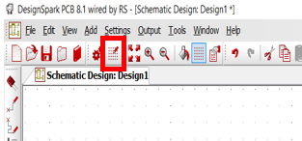

1. Click on ‘T’ for adding text. Or you can click on the highlighted icon.

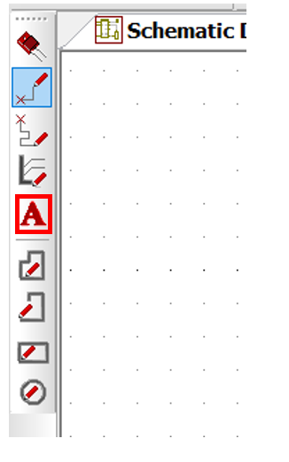

1. If you are unable to find the desired components, you may create a foot-print of the component by yourselves. You may follow this link below.

<https://designspark.zendesk.com/hc/en-us/articles/115003968769-How-do-I-create-my-own-components->